Lead Management Process
- All enquiries/leads will be created in the system only by the Lead User, Ms.Sandhiya. While creating the lead, Ms.Sandhiya will select the required Lead Source. - Correct
- Based on the selected Lead Source, the system will automatically fetch the configured Segment and Territory. The HOD configured against the selected Segment will also be automatically assigned to the lead. – It should fetch the business segment and HOD only not Territory
- The HOD will review the enquiry and perform the required activities, such as contacting the customer, understanding the requirement, and evaluating the opportunity. The HOD will update the feedback in the lead. - Correct
- If the enquiry is valid and suitable for further processing, the HOD will assign the lead to the appropriate Salesperson. Once assigned, the lead status will change from New to Allotted. - Correct
- If the enquiry is not valid or does not require further action, the HOD can select the appropriate status from the available selection field. - Correct
- Once the lead is allotted, it will be visible in the Salesperson's login so that they can take the necessary action. – Correct (eventhough it is assigned to the salesperson, the enquiry and the activities done by the salesperson should be viewed by respective HOD simultaneiusly)
- The Salesperson will perform the required follow-up activities with the customer and continuously update the feedback in the lead. – Correct
- Once the Salesperson confirms the requirement and the opportunity is finalized, the Salesperson will move the lead/pipeline to the Won stage. – Won should be changed to Quote Requested status
- If a quotation is required, the Salesperson will raise a quotation request to the Secretary from the lead. – Correct
- The Secretary will receive the quotation request, prepare the quotation based on the requirement, and attach the prepared quotation to the lead in the system. – Correct
- Once the Secretary attaches the quotation, the lead will be reassigned to the respective Salesperson who originally handled the opportunity by secretary. Before this step the quotation must be approved by respective HOD and after approval only the secretary will reassign it to the salesperson
- The Salesperson will be able to access the attached quotation for further customer follow-up and subsequent processing. – Correct
- Throughout the entire process, the system will maintain the Lead Source, Segment, Territory, HOD, Salesperson, Stage/Status, Activities, Feedback, Quotation Request, and Quotation Attachment to provide complete visibility and traceability of the enquiry. . – Correct
- And at each stage of the process, the system will maintain the allocated person and feedback for proper tracking. . – Correct
After the project finalised, the following table should be enabled (only at the finalized stage) in the pink highlighted space:
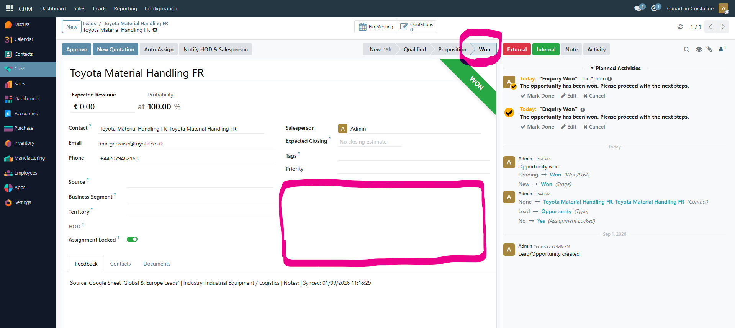
Total Project Value |  |  | Payment Receipt
Project Finalised Value |  |  | Advance Payment Received:
TAX |  |  | 2nd Payment Received:
Packaging & Freight Charges |  |  | 3rd Payment Received:
Transportation Charges |  |  | 4th Payment Received:
Installation & Commissiong Charges |  |  | 5th Payment Received:
Total Project Value |  |  | 6th Payment Received:
 |  |  | Balance Pending Payment (if any)

